Use-Case Realization Report
Manage Employee-Role

Issue <1.0>
Revision History
Date | Issue | Description | Author
30/JUL/2011 | 1.0 | First version | Alvin Chang

Table of Contents
1. Brief Description 4
2. Flow of Events 4
3. Interaction Diagrams 4
3.1 Add Employee-Role 4
3.2 Initiate Employee-Role UI 4
3.3 Remove Employee-Role 5
4. Participating Objects 5
5. Class Diagrams 6
5.1 Manage Employee-Role 6

Use-Case Realization Report
Manage Employee-Role

Brief Description

This use case enables a department manager to manage the roles held by any particular employee. This includes the addition, and removal of employee-role relationship records.

Flow of Events
The standard flow of events for this use case and any exceptions are described in the following subsections. See section 3 for an overview of the participating Actors and Domain Objects.

2.1 Add Employee-Role (Standard Flow)

- Department Manager navigates to EmployeeRolePage via MainPage
- A list of available employees and a list of available roles will be displayed
- Department Manager selects an employee, and selects the roles to be assigned to the employee.
- Department Manager confirms role assignment.
- System will update role assignment into database.
- This marks the end of this use case.

2.2 Remove Employee-Role (Standard Flow)

- Department Manager navigates to EmployeeRolePage via MainPage
- A list of available employees and a list of available roles will be displayed
- Department Manager selects an employee, and will be shown the list of roles already assigned to the employee.
- Department Manager removes the role(s) from employee.
- Department Manager confirms role assignment.
- System will update role assignment into database.
- This marks the end of this use case.

Interaction Diagrams

Add Employee-Role
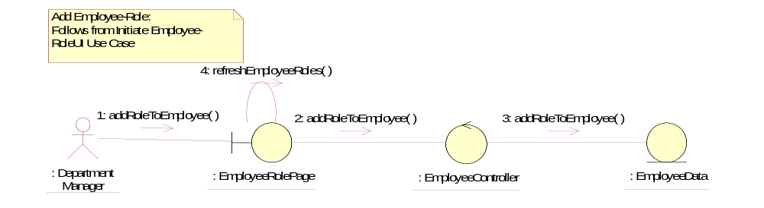

Initiate Employee-Role UI
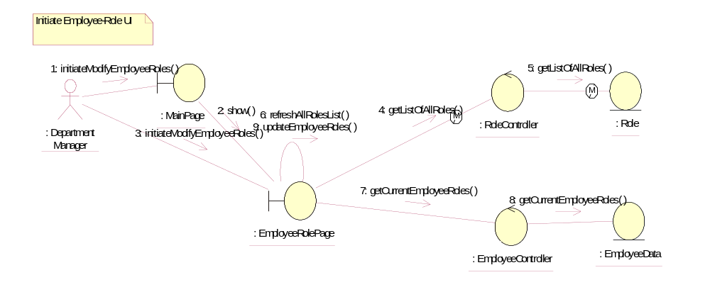

Remove Employee-Role
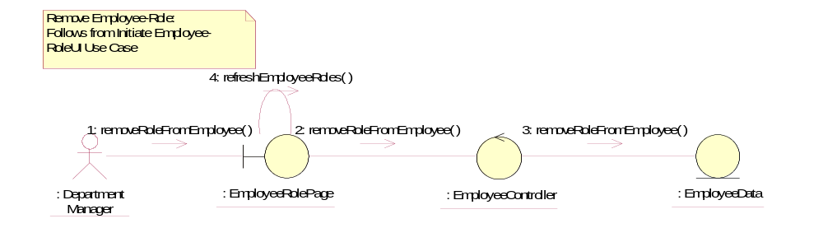

Participating Objects
: Department Manager
This actor represents the Department Manager of Golden Gravure.

: EmployeeController
This object controls the operations of the Employee object

: EmployeeData
This object contains information about the employee

: EmployeeRolePage
This page represents the UI where the Department Manager will add / remove the roles to / from the employee.

: Role
This object contains information about the roles.

: RoleController
This object controls the operations of the Role object.

: MainPage
This page represents the UI where the user of the system will first enter, and act as a launchpad for the other various pages within the system.

Class Diagrams

Manage Employee-Role
